Students Name
Institution Name
Date of Submission

Introduction
The National Centre for Health Statistics (NCHS) of the Centres for Disease Control and Prention (CDC) collects, analyses, and disseminates data on the health status of U.S. residents. The results of surveys, analyses, and studies are made known through a number of data release mechanisms including publications, mainframe computer data files, CD-ROMs (Search and Retrieval Software, Statistical Export. The National Health and Nutrition Examination Survey (NHANES) is a periodic survey conducted by NCHS. The third National Health and Nutrition Examination Survey (NHANES III), conducted from 1988 through 1994, was the seventh in a series of these surveys based on a complex, multi-stage sample plan. It was designed to provide national estimates of the health and nutritional status of the United States' civilian, noninstitutionalized population aged two months and older.
Data from NHANES III are being released in five public release data files:
NHANES III Household Adult Data File (Catalog Number 77560)
NHANES III Household Youth Data File (Catalog Number 77550)
NHANES III Examination Data File (Catalog Number 76200)
The National Health and Nutrition Examination Survey (NHANES) is a periodic survey conducted by NCHS. The third National Health and Nutrition Examination Survey (NHANES III), conducted from 1988 through 1994, was the seventh in a series of these surveys based on a complex, multi-stage sample plan. It was designed to provide national estimates of the health and nutritional status of the United States' civilian, noninstitutionalized population aged two months and older.
Data from NHANES III are being released in five public release data files:
NHANES III Household Adult Data File (Catalog Number 77560)
NHANES III Household Youth Data File (Catalog Number 77550)
NHANES III Examination Data File (Catalog Number 76200)
NHANES III Laboratory Data File (Catalog Number 76300)
NHANES III Dietary Recall Data Files (Catalog Number)
Methodology
This document includes the documentation for the NHANES III Laboratory Data File and also contains a general overview of the survey and the use of the data files. The general overview includes five sections. The first section, entitled "Guidelines for Data Users," contains important information about the use of the data files. The second section, "Survey Description," is a brief overview of the survey plan and operation. The third section, “Sample Design and Analysis Guidelines," describes some technical aspects of the sampling plan and discusses some analytic issues particularly related to the use of data from complex sample surveys. The "Data Preparation and Processing Procedures" section describes the editing conventions and the codes used to represent the data. The last and fifth section, "General References," includes a reference list for the survey overview sections of the document.
Public Use Data Files for the third National Health and Nutrition Examination Survey will also be available from the National Technical Information Service (NTIS). A list of NCHS public use data tapes available for purchase from NTIS may be obtained from the Data Dissemination Branch. Copies of all NHANES III questionnaires and data collection forms are included in the Plan and Operation of the Third National Health and Nutrition Examination Survey, 1988-94 (NCHS, 1994; U.S. DHHS, 1996). This publication, along with detailed information on NHANES procedures, interviewing, data collection, quality control techniques, survey design, nonresponse, and sample weighting can be found on the NHANES III Reference Manuals and Reports CD-ROM (U.S. DHHS, 1996). Information on how to order this CD-ROM is available from the Data Dissemination Branch at NCHS at the address and telephone.

NHANES III Background Documents
o The Plan and Operation of the Third National Health and Nutrition Examination Survey, 1988-94, (NCHS, 1994; U.S. DHHS, 1996) provides an overview of the survey and includes copies of the survey forms.
o The sample design, nonresponse, and analytic guidelines documents on the NHANES III Reference Manuals and Reports CD-ROM (U.S. DHHS, 1996) discuss the reasons that sample weights and the complex survey design should be taken into account when conducting any analysis.
o Instruction manuals, laboratory procedures, and other NHANES III reference manuals on the NHANES III Reference Manuals and Reports CD-ROM(U.S. DHHS, 1996) are also available for further information on the details of the survey.
Analytic Data Set Preparation
o Most NHANES III survey design and demographic variables are found only on the Adult and Youth Household Data Files. In preparing a data set for analysis, other data files must be merged with either or both of these files to obtain many important analytic variables.
o All of the NHANES III public use data files are linked with the common survey participant identification number (SEQN). Merging information from multiple NHANES III data files using this variable ensures that the appropriate information for each survey participant is linked correctly.
o NHANES III public use data files do not have the same number of records on each file. The Household Questionnaire Files (divided into two files, Adult and Youth) contain more records than the Examination Data File because not everyone who was interviewed completed the examination. The Laboratory Data File contains data only for persons aged one year and older. The Individual Foods Data File based on the dietary recall has multiple records for each person rather than the one record per sample person contained in the other data files.
o For each data file, SAS program code with standard variable names and labels is provided as separate text files on the CD-ROM that contains the data files. This SAS program code can be used to create a SAS data set from the data file.
o Modifications were made to items in the questionnaires, laboratory, and examination components over the course of the survey; as a result, data may not be available for certain variables for the full six years. In addition, variables may differ by phase since some changes were implemented between phases. Users are encouraged to read the Notes sections of this document carefully for information about changes.
o Extremely high and low values have been verified whenever possible, and numerous consistency checks have been performed. Nonetheless, users should examine the range and frequency of values before analysing data.
o Some data were not ready for release at the time of this publication due to continued processing of the data or analysis of laboratory specimens. A listing of those data are available in the general information section of each data file.
o Confidential and administrative data are not being released to the public. Additionally, some variables have been recoded to help protect the confidentiality of the survey participants. For example, all age-related variables were recoded to 90+ years for persons who were 90 years of age and older.
o Some variable names may differ from those used in the Phase 1 NHANES III Provisional Data Release and some variables included in the Phase 1 provisional release may not appear on these files.
o Although the data files have been edited carefully, errors may be detected. Please notify NCHS staff (301-436-8500) of any errors in the data file or the documentation.
Analytic Considerations
o NHANES III (1988-94) was designed so that the survey's first three years, 1988-91, its last three years, 1991-94, and the entire six years were national probability samples. Analysts are encouraged to use all six years of survey results.
o Sample weights are available for analysing NHANES III data. One of the following three sample weights will be appropriate for nearly all analyses: interviewed sample final weight (WTPFQX6), examined sample final weight (WTPFEX6), and mobile examination centre (MEC)- and home-examined sample final weight (WTPFHX6). Choosing which of these sample weights to use in any analysis depends on the variables being used. A good rule of thumb is to use "the least common denominator" approach. In this approach, the user checks the variables of interest. The variable that was collected on the smallest number of persons is the "least common denominator," and the sample weight that applies to that variable is the appropriate one to use for that analysis. For more detailed information, see the Analytic and Report. Guidelines for NHANES III (U.S. DHHS, 1996).
Referencing or Citing NHANES III Data
o In publications, please acknowledge NCHS as the original data source.
For instance, the reference for the NHANES III Laboratory Data File is U.S. Department of Health and Human Services (DHHS). National Centre for Health Statistics. Third National Health and Nutrition Examination Survey, 1988-1994, NHANES III Laboratory Data File (CD-ROM). Public Use Data File Documentation Number 76200. Hyattsville, MD.: Centres for Disease Control and Prevention, 1996. Available from National Technical Information Service (NTIS), Springfield, VA.
o Please place the acronym "NHANES III" in the titles or abstracts of journal articles and other publications in order to facilitate the retrieval of such materials in bibliographic searches.
Conclusion
The third National Health and Nutrition Examination Survey (NHANES III) was the seventh in a series of large health examination surveys conducted in the United States beginning in 1960. Three of these surveys, the National Health Examination Surveys (NHES), were conducted in the 1960's (NCHS, 1965; NCHS, 1967; NCHS, 1969). In 1970, an expanded nutrition component was added to provide data with which to assess nutritional status and dietary practces, and the name was changed to the National Health and Nutrition Examination Survey (Miller, 1973; Engel, 1978; McDowell, 1981).

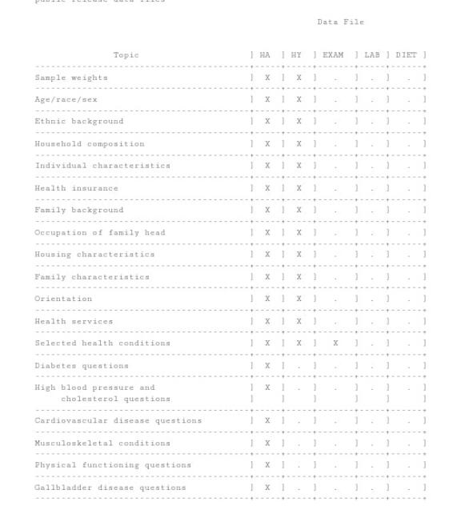
Appendix
